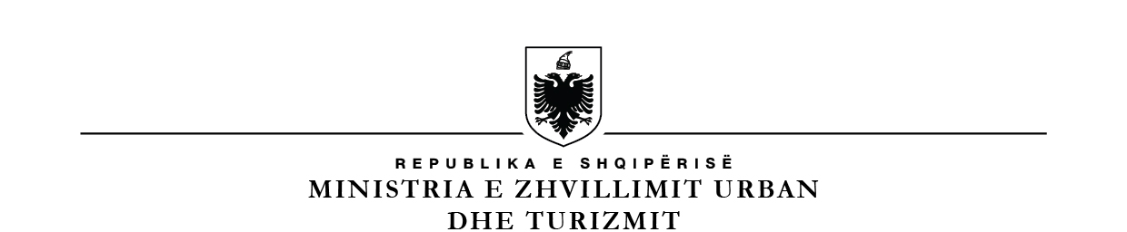 **SHOQËRIA “ALBPETROL” SH.A.**

Nr. ______ Prot. Patos më, ___.___.2023

**ANNOUNCEMENT OF AUCTION**

1. **Selling Authority: “**Albpetrol “ Sha Patos, Str. Fier – Patos km 7.
2. **Auction date:** 07.07.2023, at 11:00
3. **Type of auction procedure: “**Open procedure”.
4. **Object for Sale:** Sale of crude oil, quantity 105,691 ton
5. **Removal Term:** 12 months from date of signing the contract
6. **Short description of object for sale**: Sale of crude oil, quantity 105,691 ton
7. **Innitial Value:**

**FOB terms:**

Innitial price for unit is:

**78.18 % Brent + K**

**At delivery point:**

Minimum initial price for unit is:

**78.18 % Brent – 3.65 USD/bbl + K**

* **78.18 %** is the coefficient that represents the average oil characteristics (specific weight, oil acidity, Sulfur percentage %).
* Brent is the price in USD/bbl of Brent i Platts, published in the Public Procurement Bulletin.
* **3.65** USD/bbl average total cost (transport, storage, stocking, product analyses, insurance).
* K- is the USD/bbl value bided by the offerer over the minimum sale calculated with formula (K>0).

1. **Location of crude oil: Albpetrol sha Patos:** At delivery point, Usojë Station, Visokë Station, Gorisht Station, Zharrëz Station, Kuçovë Station, Amonicë Station.
2. **Auction to be held at:** Ministry of Infrastructure & Energy,Str. Abdi Toptani No. 1, Ist floor, Meetings Hall, Tirana.
3. **Deadline for submission of requests for participation:** at protocol office 1th floorat Ministry of Infrastructure & Energy on July,07, 2023, at 11:00.
4. **Date of opening of offers/bids:** date July, 07, 2023, at 11:00,Ministry of Infrastructure & Energy,Str. Abdi Toptani No. 1, Ist, Meetings Hall, Tirana.
5. **Information on auction documents:**

The auction documents can be withdrawn at the selling authority by submitting a written request or at Albpetrol sh.a official website: [www.albpetrol.al](http://www.albpetrol.al) and website of Ministry of Infrastructure & Energy [www.infrastruktura.gov.al](http://www.infrastruktura.gov.al).

Documents with payment:

|  |  |  |  |
| --- | --- | --- | --- |
| Yes | □ | No | X |

1. Request for participation, documents and informations requested to be submitted by the pruchasing candidate in physical copies, by mail or hand, before the auction date and time, at the place set in the auction documents.

**ADMINISTRATOR**

**Eltar DEDA**